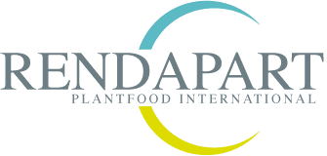
Rendapart is a company located in Aalst Belgium specialized in the production and packing of organic and organo-mineral fertilizers. It is a financially strong and prospering family-owned company with a long tradition, introducing new production techniques and performing product innovation on a continuous base. The well-known brand VIANO offers a complete range of garden products, fertilizers (single and composed), soil enhancers, potting soil, groundcovers etc. Actualy Rendapart is looking for :

Operator bagging department

Objectives:
Bagging of fertilizers according to procedures, planning and related qualitative and quantitative targets, to obtain a ready to sell product.
Function :
As operator you are responsible for :

- Reception of the product
- Bagging of the product verifying quantity, quality, and conformity
- Securing the pallet loads with a cover to optimize stability and appearance
- Supply of packaging materials to the production lines (pallets, cardboards ,foils ,big bags,..)
- Bedienen van diverse machines in functie van het afzakken van meststoffen
- Supervision of the equipment and the production
- Equipment changeover
- Technical controls on the installation and warning maintenance when necessary
- Daily maintenance activities

Profile :
- You have a forklift driving license, or are preapered to get one
- You speak English/Dutch/French
- You have first job experience or an extended production scholarship
- You are prepared to work in 3 shifts

Offer: Rendapart offers a challenging job, with a lot of variation in an interesting and dynamic environment.

Interested? If you are interested in this unique job opportunity, please send your cv and motivation letter to Frans Krauch, hello@viano.be , Rendapart NV, Wijngaardveld 36, B-9300 Aalst, Belgium.

